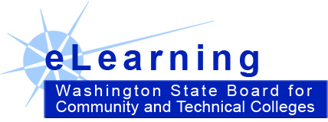

2009-2010 Quality Matters Plan

- SBCTC buys a Quality Matters (QM) Statewide Subscriber membership = $5,000 / year
  - Allows SBCTC to buy college “affiliate” memberships at a discount.
  - One seat in QM institutional representative training – Boyoung Chae will be trained.
  - One seat/year for QM “train-the-trainer” training (SBCTC has 2 seats for FY10).
    - Boyoung and Scott Dennis will be trained.
    - Allows trained SBCTC eLearning staff to teach “Applying the QM Rubric” course.
      - SBCTC eLearning staff will offer this course at colleges not involved with QM as an educational outreach effort… to encourage additional QM participation.
      - Can download and use QM instruction materials.

- SBCTC will pay for college’s annual $1000 / year QM college “affiliate” fee. $33,000.00 ($1000 x 33 affiliates)
  - Access to QM rubric.
  - Discounts on QM series training.
  - One seat in QM institutional representative training.
  - License to conduct QM “Applying the QM Rubric” training.
  - License to have master and peer reviewers review in-system courses.

- SBCTC will pay for paper QM rubrics / workbooks: 50 per college $16,417.50 ($9.95 x 50 x 33 affiliates)

- SBCTC will pay for one faculty per college per year to attend a full series of QM training – up through QM Independent Trainer. ($750 x 28 colleges = $21,000)
    - Online “Applying the QM Rubric” and “Peer Reviewer Certification” ($250)
    - QM “train-the-trainer” seat per college per year ($500)

- SBCTC will pay for one faculty per college per year to attend a full series of QM training – up through QM Master Reviewer. $16,500 ($500 x 33 colleges)
  - Online “Applying the QM Rubric” and “Peer Reviewer Certification” - $250
  - Fill out QM application & MOU and participate in two QM-managed peer reviewers - $0
  - Master Reviewer Training - $250
  - Total: $500 per faculty

